

THE HERITAGE

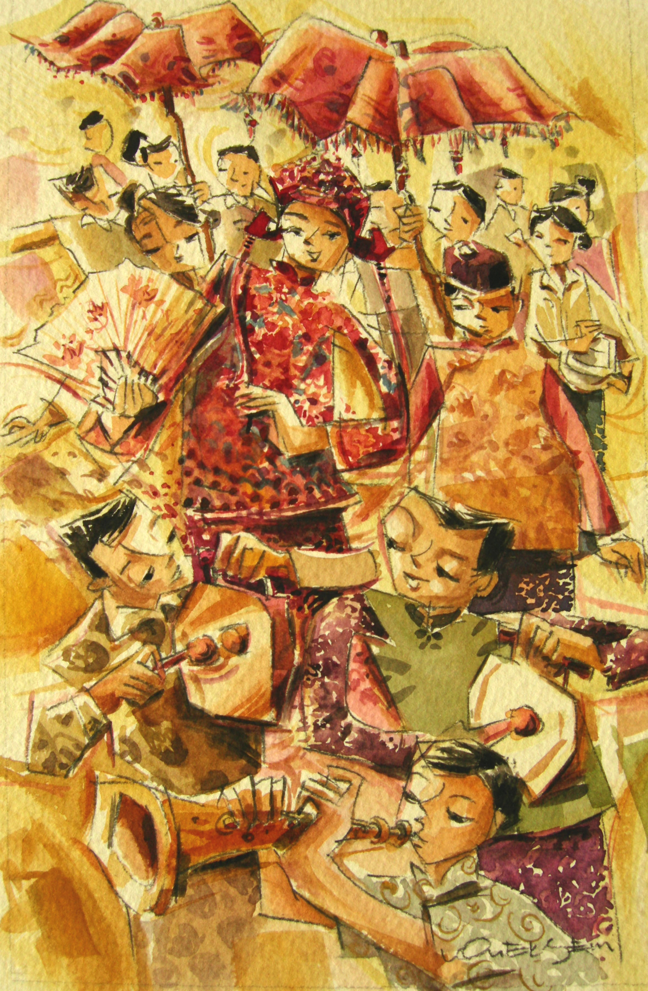
The Wedding Procession
On the way to the bride’s house, the groom is accompanied by a pak chindek, two best men, a cymbal player, a flutist and two gong masters. The procession is led by professional Indian attendants carrying the groom’s lanterns and banner, followed by Chinese musicians playing the serunee wedding procession music. A display of gifts for the bride comes next, and these are arranged on large brass trays that are carried shoulder-high by Indian attendants. They are escorted by the groom’s close friends.

